Product Name = Nexxus MI
Product Abbreviation = MI
Product Mark =
Ver Num (Application Version) = 11
Custom (Full Document Title) = EXERCICE BOOK
Doc Type = NEXXUSETL ADVANCED CONNECTOR
Doc Type Abbreviation = FDD
Doc Name = DocName
Rev Num (Document Version) = 11
DocDate = September 15, 2015
Copy Year = 2015
Client Name Full (Prepared For) = For Internal and External Use
Preparer Name Full (Prepared By) = Corporate Training Center
Author = B CARETTE
Blank =

Nexxus MI
Application Version: 11
EXERCICE BOOK
NEXXUSETL ADVANCED CONNECTOR
Document Version: 11
Publication Date: September 15, 2015
For Internal and External Use
Prepared by: Corporate Training Center
©2015 IMS Health Incorporated and its affiliates. All rights reserved. Trademarks are registered in the United States and in various other countries.The information contained in this document is proprietary and confidential information of IMS Health and its subsidiaries and may not be duplicated,published or disclosed to a third party, in whole or in part, without prior written permission from an authorized IMS Health representative. The useand disclosure of this information are further subject to the terms and conditions of any applicable agreement between the recipient and IMS Health, including any governing service, confidentiality or non-disclosure agreement.
IMS Health
137 rue d'Aguesseau
92641 Boulogne-Billancourt Cedex

Publication Record
Application Version | Doc Version | Publication Date | Author | Document Checker | Overview of Versions
11 | 1.0 | Septembre 15, 2015 | B CARETTE |  | Initial publication
12 | 2.0 | January 21, 2016 | B. CARETTE |  | Modification 5.2.3 exercise
Contents
Publication Record 2
1. CONTEXT 4
2. CLIENT TERMINOLOGY 5
3. GLOBAL OBJECTIVE OF THE FIRST EXERCISE 6
4. CONFIGURATION DONE ON ENTITY MANAGEMENT 7
4.1 Requirements 7
4.2 Publications 7
4.3 Publications Summary 8
5 interface creation in NexxusETL 11
5.1 Requirements 11
5.2 Environment Set-up 12
5.2.1 12
5.2.2 12
5.2.3 12
5.3 Dataloading jobs in NexxusETL 13
5.3.1 13
5.3.2 13
5.3.3 13
5.3.4 14
5.3.5 14
5.3.6 14
6 Export jobs in NexxusETL 15
6.1 Standard Export 15
6.1.1 15
6.1.2 15
6.2 Specific Export 16
6.2.1 16

CONTEXT
Read each exercise carefully before beginning.
Complete each exercise one after the other.

Each time this symbol * appears in the exercises, please add your respective number to the concerned item.

CLIENT TERMINOLOGY
Term | Definition | Ims Health Equivalent
Publication | Scientific text printed as an article in a Magazine or as a Book. | None
H-index | The h-index is an index that attempts to measure both the productivity and impact of the published work of a scientist or scholar. | None

GLOBAL OBJECTIVE OF THE FIRST EXERCISE
The client wants to load additional data in Nexxus MI.
The data will be displayed on the Medical Professional Profile.
Two new sections will be added on the ‘Essential’ tab to collect information about the Medical Professional’s publications.
Specific interfaces must be created in NexxusETL to load the data.
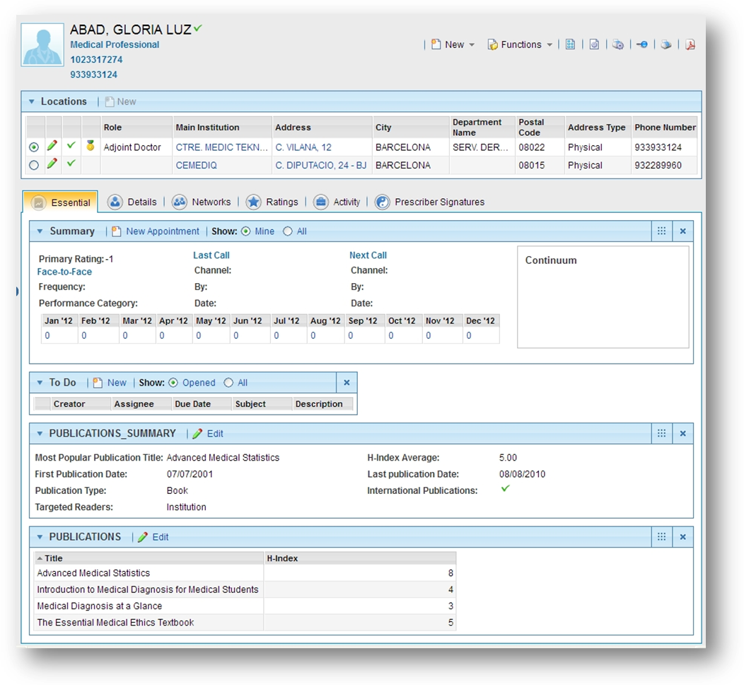

CONFIGURATION DONE ON ENTITY MANAGEMENT

Requirements
Two new dynamic tables has been created in ENTITY MANAGEMENT.
A specific Layout has been created for each new table.
The first table is called PUBLICATIONS. Its associated layout is a grid.
The second table is called PUBLICATIONS_SUMMARY. Its associated layout is 2 columns of fields section.
These specific layouts are displayed on all Medical Professionals profile, on the Essential tab.

Publications
The PUBLICATIONS dynamic table stores all the publications written by a Medical Professional.
The table contains the following fields:
- External_ID (text)
- Title (text)
- H-Index (Number)
The H-Index is included between 1 and 9.
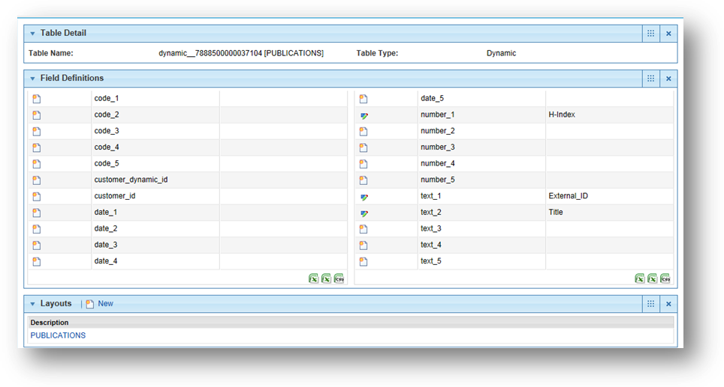

Its associated layout displays all the fields except External_id in a grid.
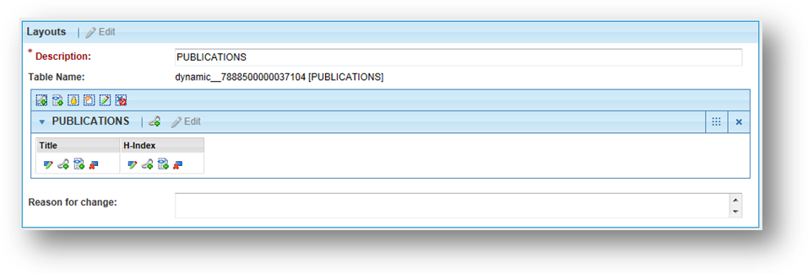

Publications Summary

The PUBLICATIONS_SUMMARY dynamic table stores consolidated data about the Publications written by the Medical Professionnal.
The table contains the following fields:
- External_ID (text)
- Most Popular Publication Title (text)
- H-Index Average (Number, Float)
- International Publications (code, Check Box)
- Publication Type (code / Dropdown)
- First Publication Date (date)
- Last Publication Date (date)

The Most Popular Publication Title is taken from the Grid and is equal to the Title with the highest H-Index (to be calculated in NexxusETL).
The Average H-Index is an average of all the H-Index from the Grid for the same customer (to be calculated in NexxusETL).

The Publication Type is a drop down list with the following values:
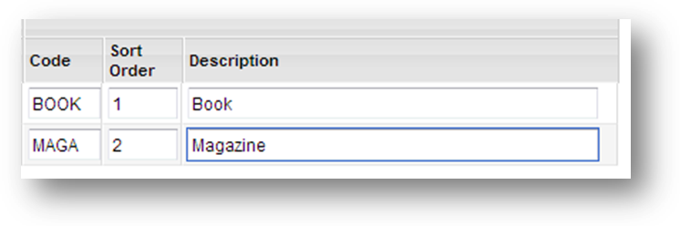
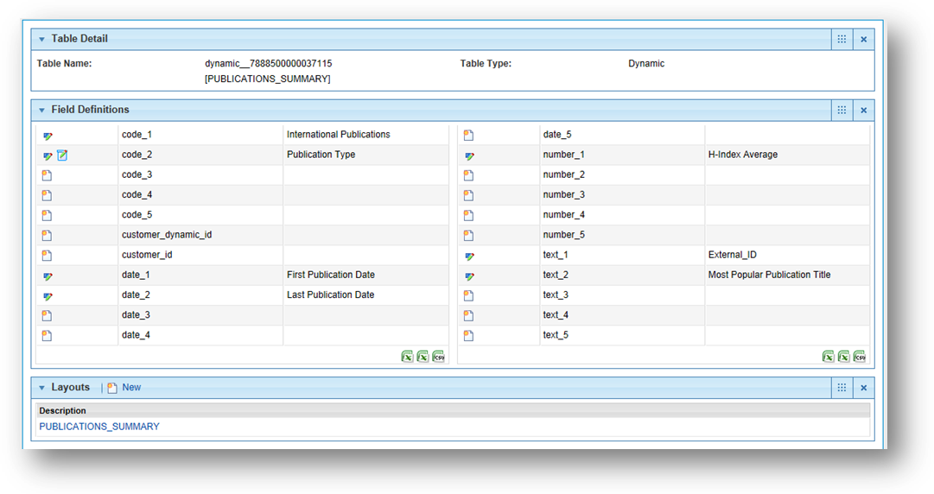

Its associated layout displays all the fields except External_id in a 2 columns section.

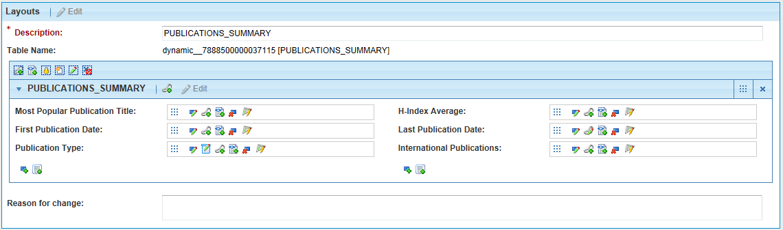

A dependency has been set on the Last Publication Date to set it always greater than First Publication Date.
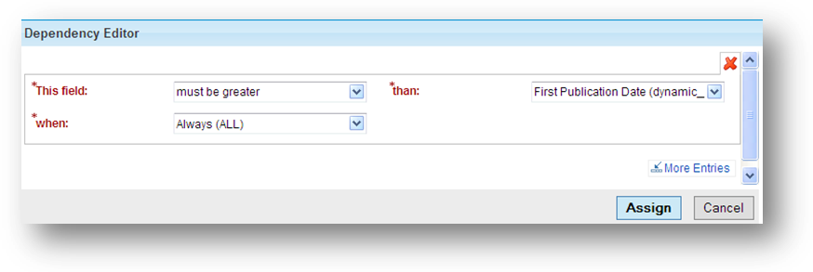

interface creation in NexxusETL

Requirements
Once the Configuration is archieved, the client wants to load data in the PUBLICATIONS and the PUBLICATIONS_SUMMARY tables.
Two specific jobs must be created in NexxusETL, one per table.

Environment Set-up
Ref # | Description
OBJECTIVE: create the project and import the Variables/Resources
In NexxusETL, create a new project on the Tenant dedicated Structure.
The name of the project must be NETL*
Import the TEAM Job and the DLS_SCHEDULER_DOWNLOAD Job from the Global Structure
Check all the Global Variables ( $ProjectName$ ) and Resources (Database, MoveIt)

OBJECTIVE: Query the MI database within NexxusETL
Create a job to query the Nexxus MI Database and check the values of the variables used to set the DLS_MoveIt Resource (values are inherited from the tenant setup).

OBJECTIVE: create a new Variable and prepare the environment
Follow these steps to update the environment:
- Create a New Variable called ‘MoveIt’ (based on the $FTPRemoteDownloadPath$ variable that specifies the MoveItPath) to target the ImportFileToMI\NETL* directory created on purpose on the MoveIt Plaftorm.
(add explicitely the name of your project in this new Global Variable)
- Update the DLS_Scheduler_MOVG_Files task included in the DLS_SCHEDULER_DOWNLOAD Job with the new ‘MoveIt’ variable.
- Zip a text file and upload it on the ImportFileToMI\NETL* directory of the MoveIt Platform. Beware: the name of the file must respect the naming conventions of all the tasks of the DLS_SCHEDULER_DOWNLOAD Job.
- Launch the job and check that the file has been downloaded and unziped.
- Check that the directory tree on the Application Server has been created.

Dataloading jobs in NexxusETL
Ref # | Description
5.3.1 | OBJECTIVE: Load Data in the PUBLICATIONS table using simple Mapping operations.  Create a new Job called PUBLICATIONS* to load data in the PUBLICATIONS table  The IDL file must contain the following fields:  External_ID|OneKey_ID|Title|HIndex  Several Publications must be loaded for the same Medical Professional.  A Database lookup must be created to map the customer_id. The variable $CustomerExtColName$ must be used to target External_Id_2.  Note: avoid using the ‘-‘ sign in column name (use HIndex instead of H-Index)
5.3.2 | OBJECTIVE: Load Data in the PUBLICATIONS_SUMMARY table using simple Mapping operations and advanced database lookups.  Create a new Job called PUBLICATIONS_SUMMARY* to load data in the PUBLICATIONS_SUMMARY dynamic table.  The IDL file must contain the following fields:  External_ID|OneKey_ID|International Publications|Publication Type|First Publication Date|Last Publication Date  Then use Database lookups to recover the Most Publication Title (is the Publication Title with the highest H-Index in the grid for a Medical Professional) and the Average H-index (is an average of all the H-index of the grid for a Medical Professional).  $CustomerExtColName$ must be used in all lookups.  When the Interfaces are created and some data loaded, check the result in Nexxus MI.  Additional Data Control will be added later during the training.
5.3.3 | OBJECTIVE: backup the jobs  When the two jobs are tested and validated, export them in XML files. Then, Import your previous export of PUBLICATIONS_SUMMARY* and change its name to PUBLICATIONS_SUMMARY_CONTROL*.  (Alternatively you can also use the copy job feature)
5.3.4 | OBJECTIVE: Link a Nested Job to collect log files  Use the Export Job and Import Job features to retrieve a copy of the team_nested job then rename it into PUBLICATIONS_SUMMARY_CONTROL*_Nested.  Rename the tasks and the files of the PUBLICATIONS_SUMMARY_CONTROL*_Nested (use ‘Publications_Summary_Control’ instead of ‘Team’).  Insert a Nested Job task in PUBLICATIONS_SUMMARY_CONTROL*.  This Nested job will be PUBLICATIONS_SUMMARY_CONTROL*_Nested .  Link it to all the tasks with a failure condition.  Check all the fields aliases are mandatory in the Nested Job.  Load a file with a wrong OneKey_Id (you can delete the first W for example) and check if the files has been corectly created.
5.3.5 | OBJECTIVE: Insert a Control in the PUBLICATIONS_SUMMARY_CONTROL job.  Insert a control in the Mapping Task to validate the possible values of the Publication Type field (via the Validate Code Using Cegedim Framework operation, based on the possible values as set in the PUBLICATIONS_SUMMARY table in Entity Management.)
5.3.6 | Optional Exercise  OBJECTIVE: Add Controls in the PUBLICATIONS_SUMMARY_CONTROL job with a stored procedure  Beware: Make an xml backup of the project before starting.  Reorganize the PUBLICATIONS_SUMMARY_CONTROL* job with the following tasks:  File Reader > Mapping > Assign > Mapping > DatabaseWriter (in addition of the Nested Job)  In the first Mapping task add controls:  a/ on the Last Date (that must be greater than the First Date) using the Call job from the MI_DLS project as an example  b/ on the International Checkbox using the DLS_Spending job as an example (in the Sending_MAP_R task)  Test the controls and the associated log files

Export jobs in NexxusETL

Standard Export
Ref # | Description
6.1.1 | OBJECTIVE: Prepare the Standard Export Process  In addition, the Client wants to test the standard Export Process in NexxusETL:  The Standard Process will be tested on Team extraction.  Create a new Team in Nexxus MI GUI  The name of the Team must be TEAM* and the External ID1 must be NETL*  Check the presence of the Team in the table DLT_EXPORT_DATA
6.1.2 | OBJECTIVE: Understand the Standard Export Process  Import the Job Team_Exp from the Global Structure  Create a new Job named Export* where the Team_Exp Job must be nested.  Set this new job Job to export the Team  The External ID1 of the Team must be used as a filter to export only the Team created  Run the job and check the extracted file

Specific Export

Ref # | Description
6.2.1 | OBJECTIVE: Create a Specific Export Job  In addition, the Client wants to test the standard Specific Process in NexxusETL:  The Specific Process will be tested on the Team Table  Create a new Job named Specific_Export*  Two Jobs must be Nested in it:  - KOL* must extract the Name, Description, Type of all the Teams Stored in the team table where type=KOL  - PC* must extract the Name, Description, Type of all the Teams Stored in the team table where type=PC  They must extract their data in the same Excel File (named Team*.xlsx), but on two separate sheets:  KOL* on the KOL* sheet and PC in the PC sheet.  Run the job and check the extracted file

